# Global Air Transportation Network

1. INTRODUCTION

## 1.1 Overview

*This project gives us insights into the global air transportation network with tableau.* *We can also be impressed by the industry's safety record. The trends and patterns of air travel over time or by season. Certain qualities like comfort, a smooth flight, and prompt service.*

*1.2* Purpose

## *The air transport network is a key infrastructure asset. It is the only worldwide passenger and cargo transportation network, providing an essential link between individual countries and the wider global economy. Air services create significant value for passenger and freight users.*

2. Problem Definition & Design Thinking

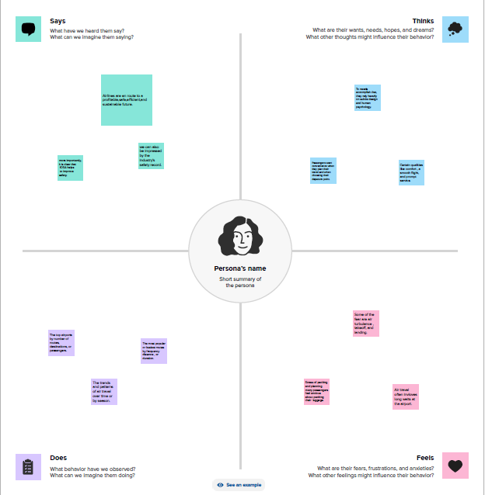 **2.1 Empathy Map**

**2.2 Ideation & Brainstorming Map**

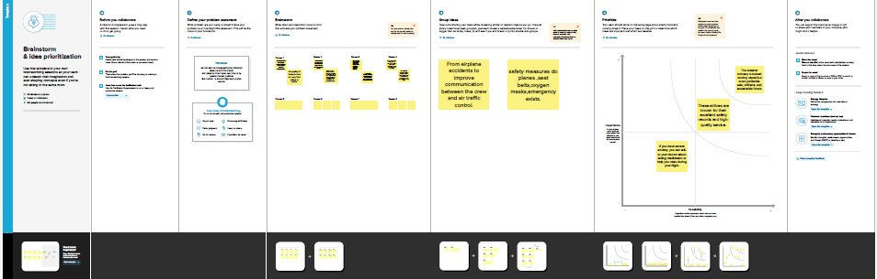

3. RESULT

Visualization

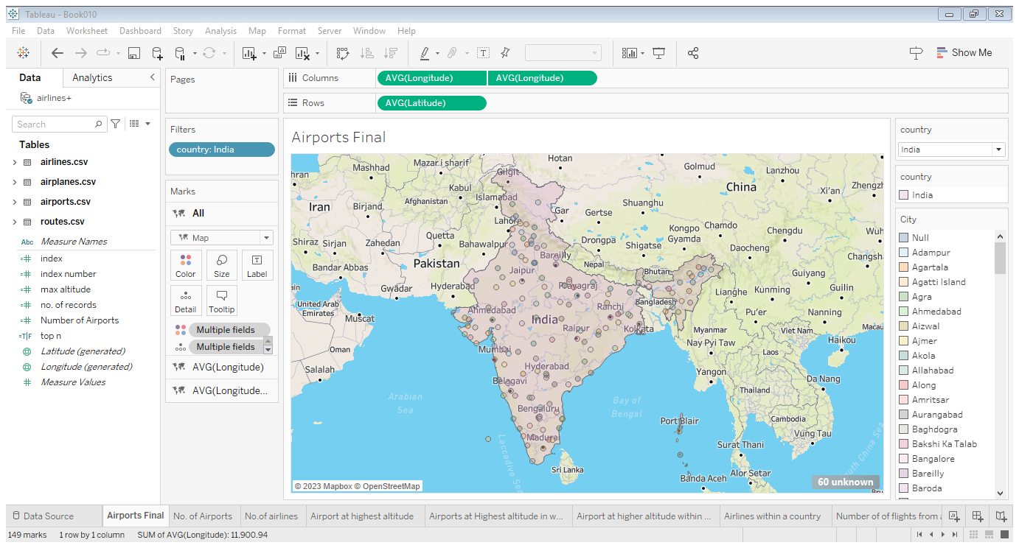

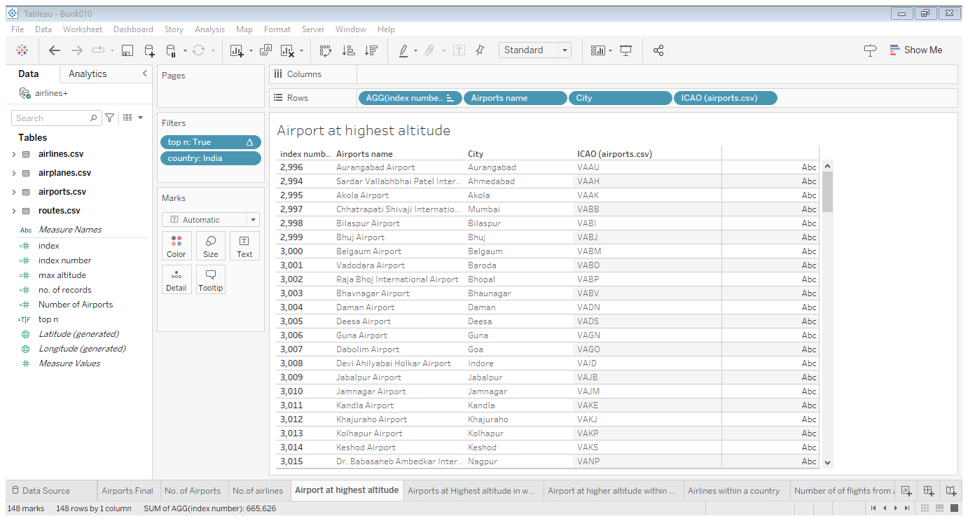

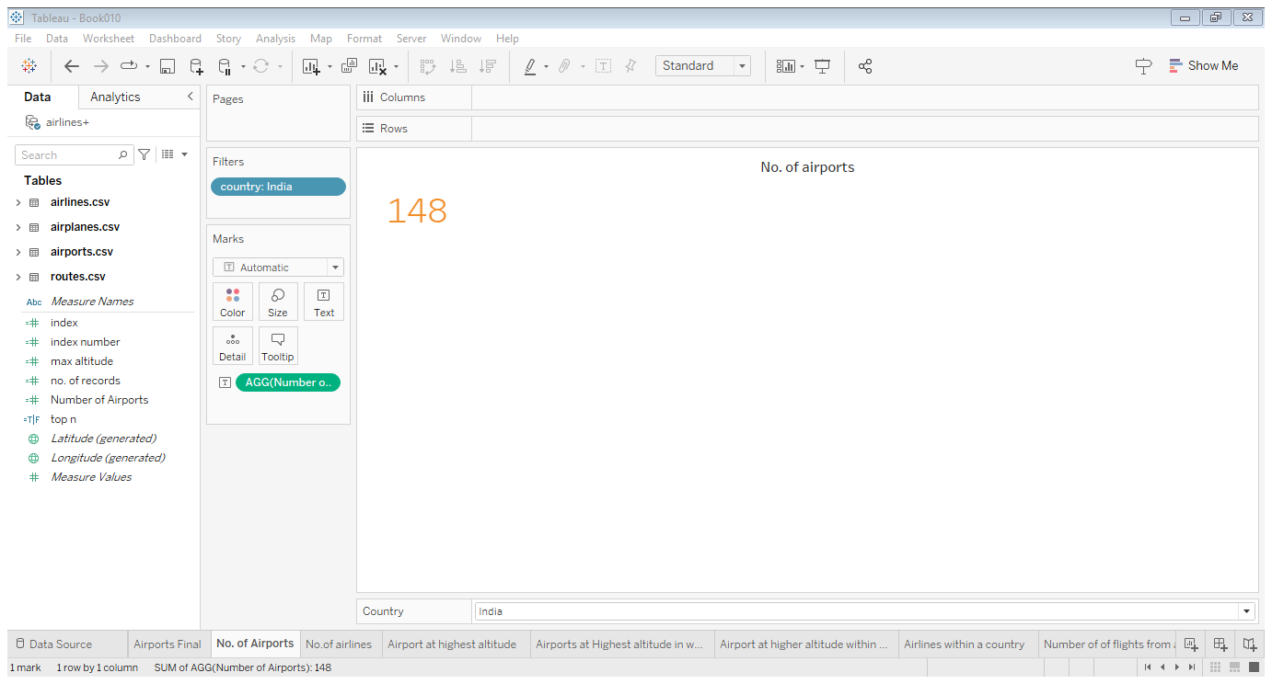

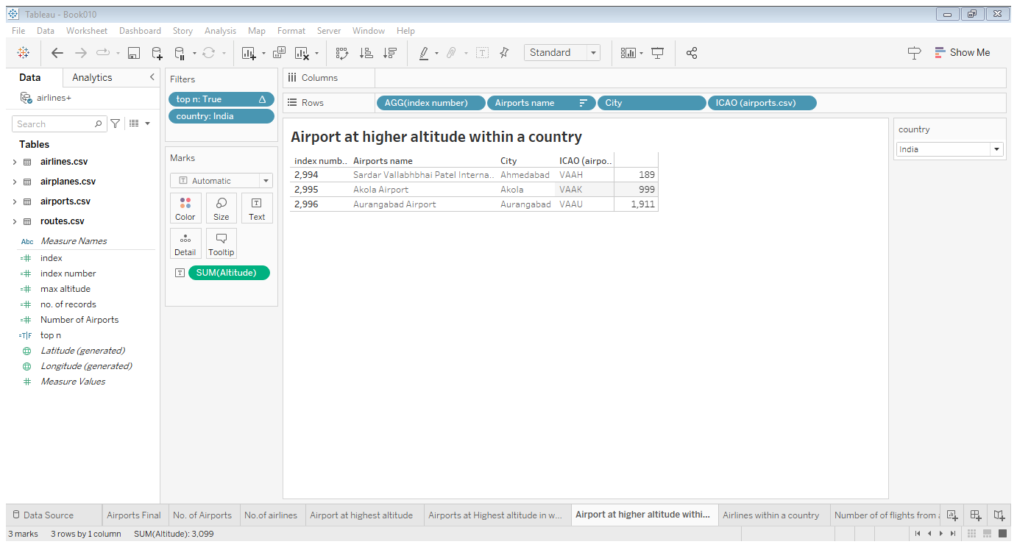

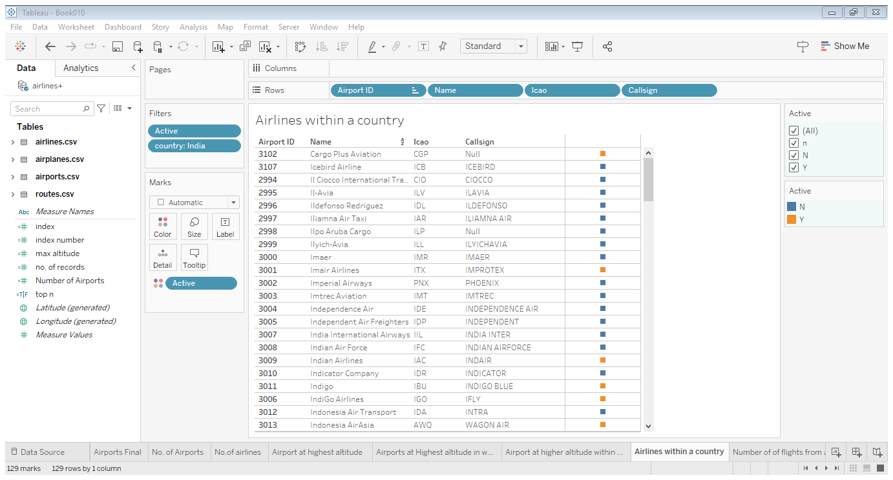

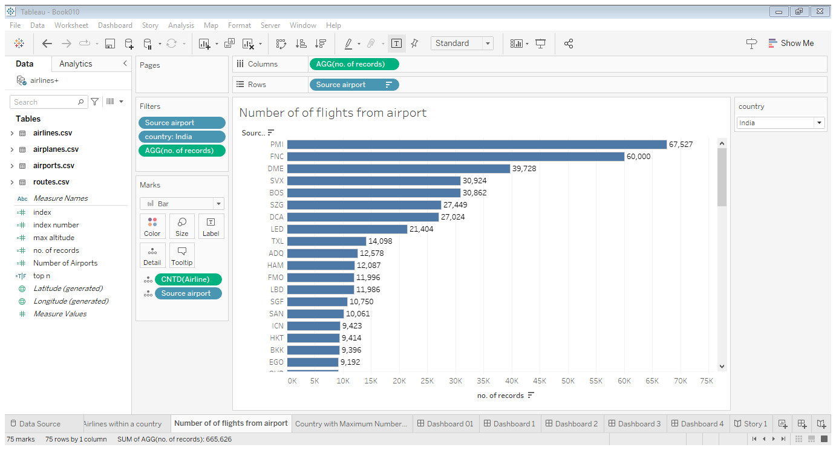

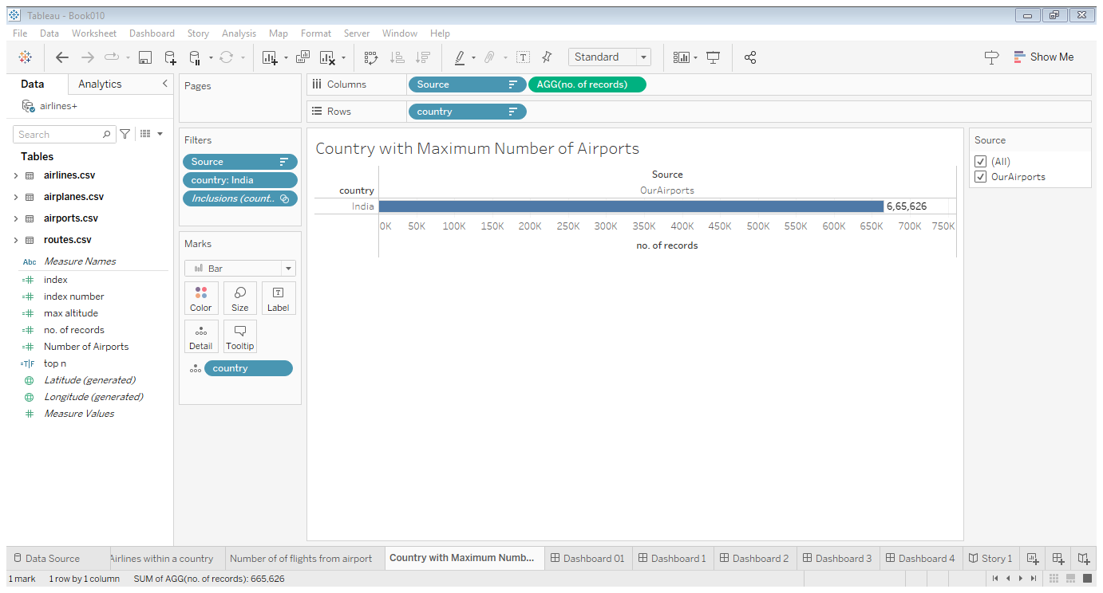

Dashboard

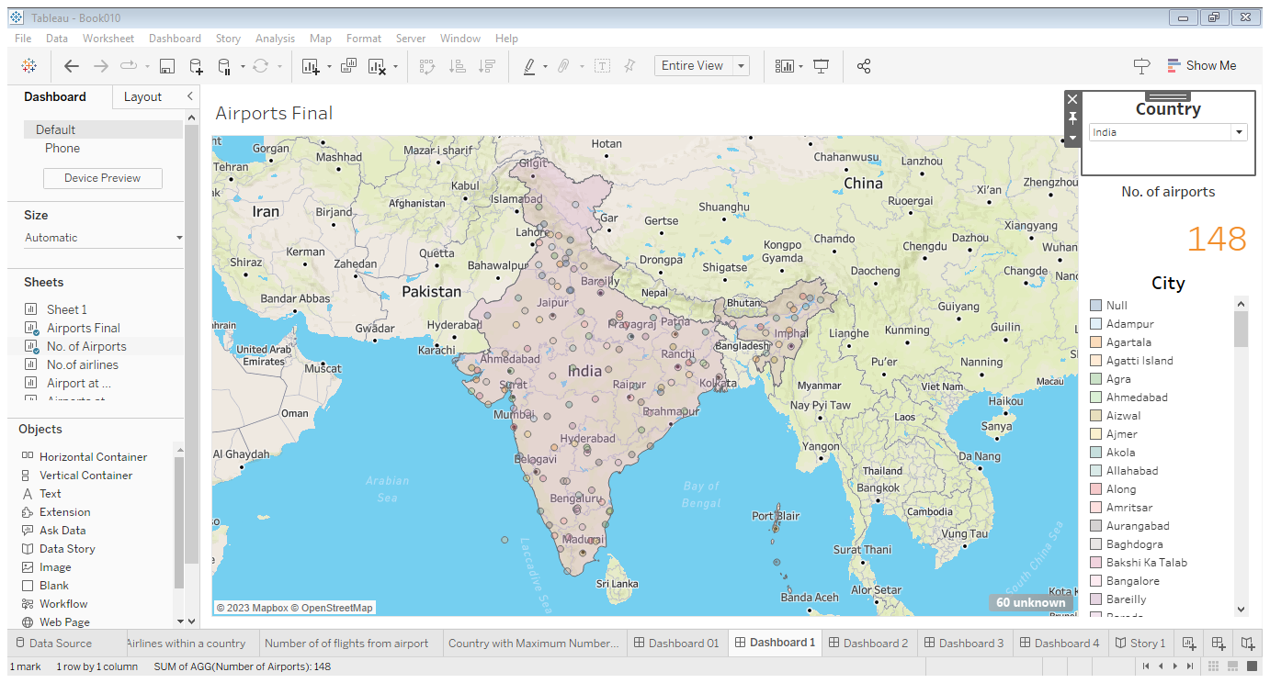

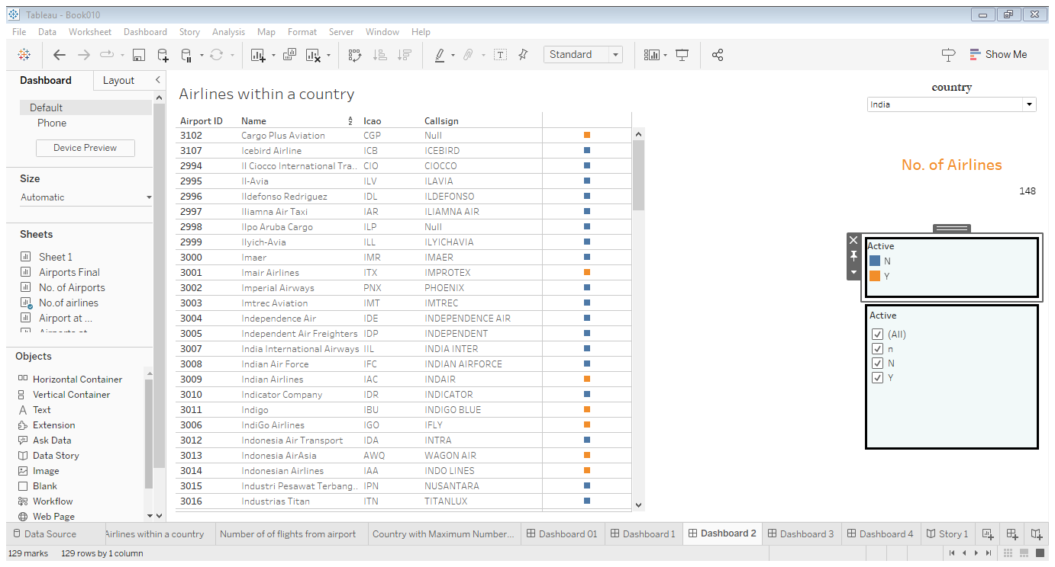

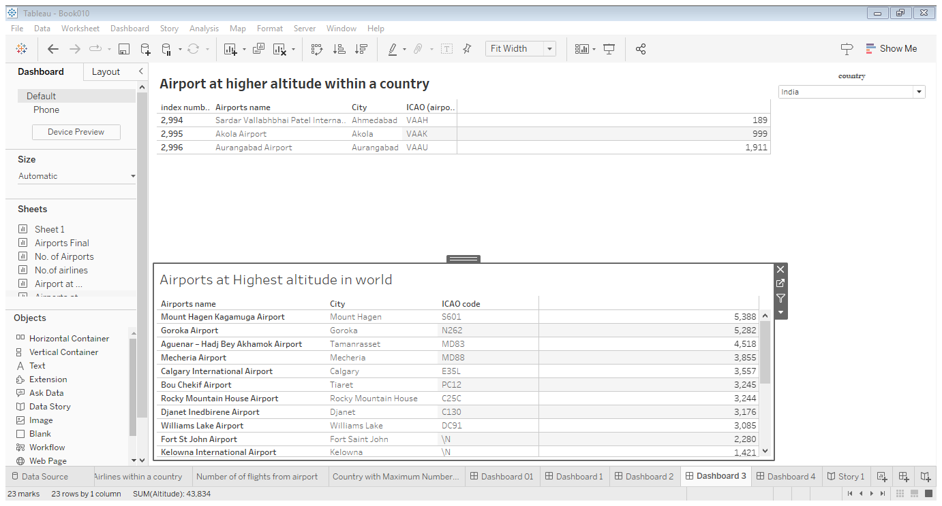

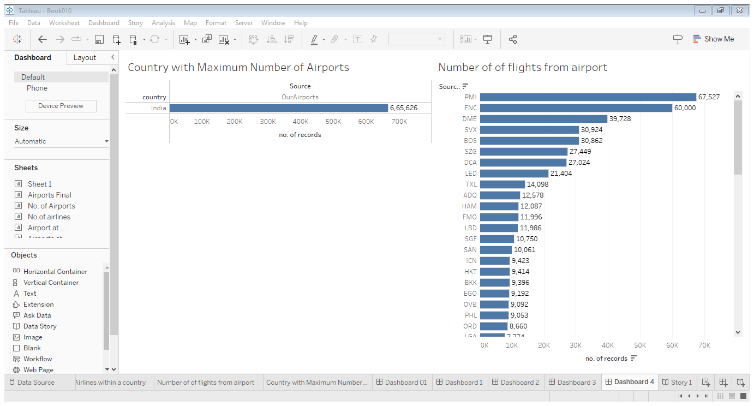

Story

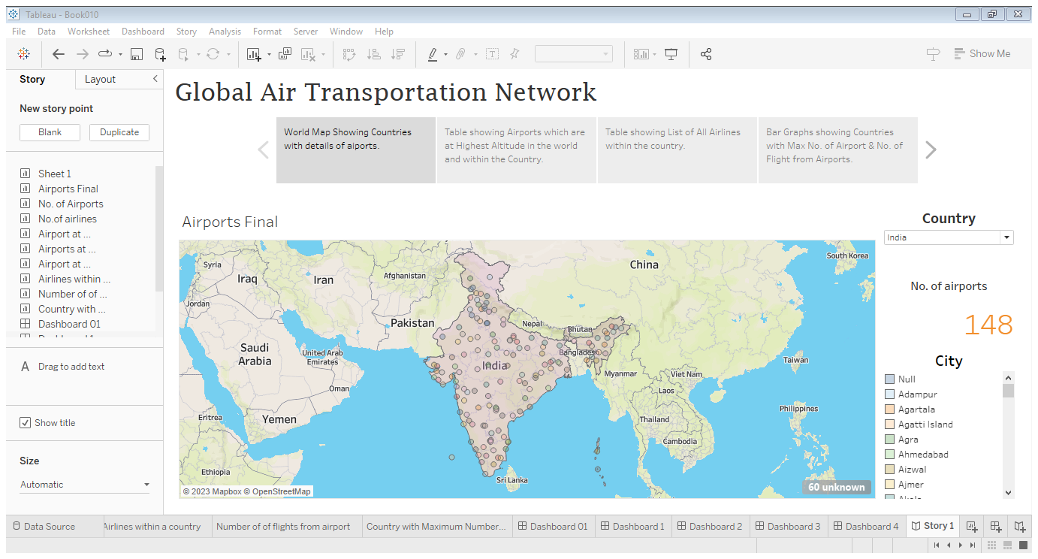

4. ADVANTAGES & DISADVANTAGES

## Advantages of Air Transport

### This project gives us insights into the global air transportation network with tableau.

### 2. Send almost everywhere your freight

 In regions that are not readily accessible to other modes of transport, air transport is considered to be the only means of transport. Open to all regions, irrespective of land interference.

3. A vast network of airlines covering nearly the whole globe is available for many airlines. This ensures that the package can be sent almost anywhere

## Disadvantages of Air Transport

1. Climate conditions that are adverse: Extreme weather will cause planes to be grounded and airports to close, halting shipments for several days and rendering the service ineffective.

2. It is not sure that we will get the accurate data, which will be an disadvantage to this project.

### 3. Some Product Limitation

There is a whole variety of materials not suitable for such productsfrom explosives, gases, batteries, fired solids and liquids, which cannot be shipped by air to name but a few**.**

5. APPLICATIONS

**The areas where this solution can be applied**

* Air transport is currently used in almost all industrial sectors and distribution chains.
* Most companies use air transport to market goods and products internationally or to deliver samples and documents related to foreign trade operations.
* The worldwide air transportation network is a critical infrastructure with high impact on mobility, trade and economy.

6. CONCLUSION

The air transport system generally includes airports, ATC (air traffic control) system, and airlines. The airports represent the ground part of the system's infrastructure handling the aircraft operated by different airlines transporting passengers and freight cargo shipments.

7. FUTURE SCOPE

New technologies are making aviation more efficient, from the use of lightweight composite materials that reduce fuel consumption to more efficient engines that produce less pollution. Improved air traffic control systems are also making air travel more efficient by reducing congestion and delays.